Uploading Documents in RHC Connect

Please use the instructions below if you are uploading more than 10 documents in the “Additional Documents” section of RHC Connect for the FCC Forms 462:

- Click on the “Upload Documents” button
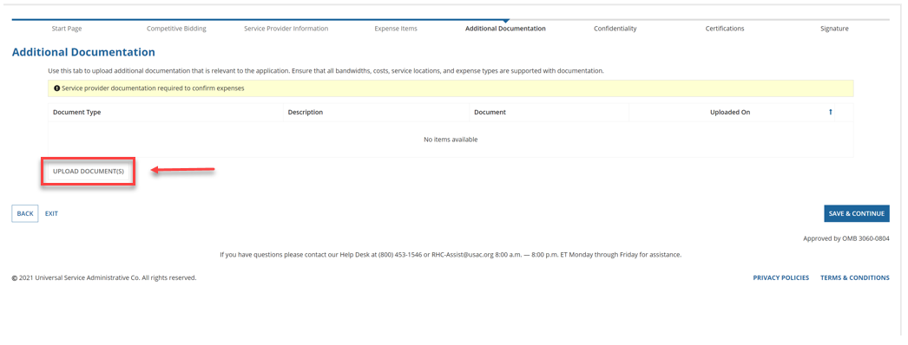

- Click on “Add Document” or do a bulk upload of up to 100 documents (see screen tip in blue)
  - Bulk uploads can handle 10 documents at a time for a maximum of 100 documents
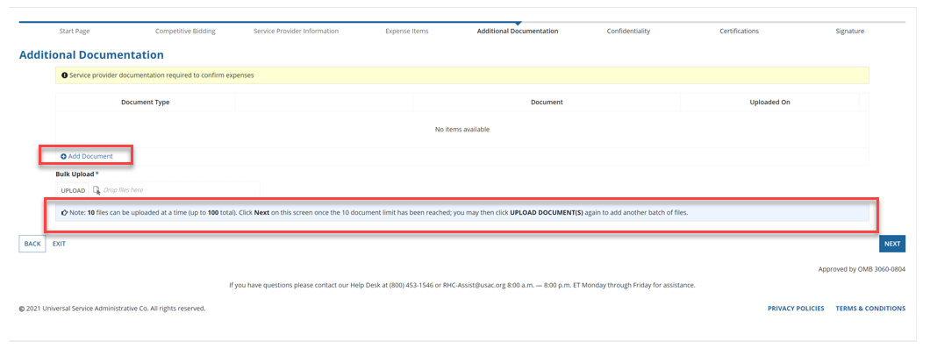

- Click the “Upload” button

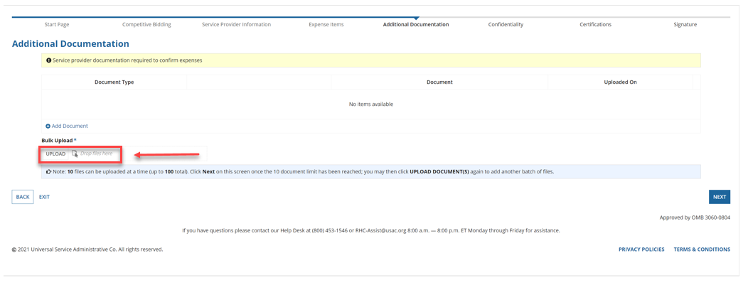

- Select the document (s) from the dialog box for your computer

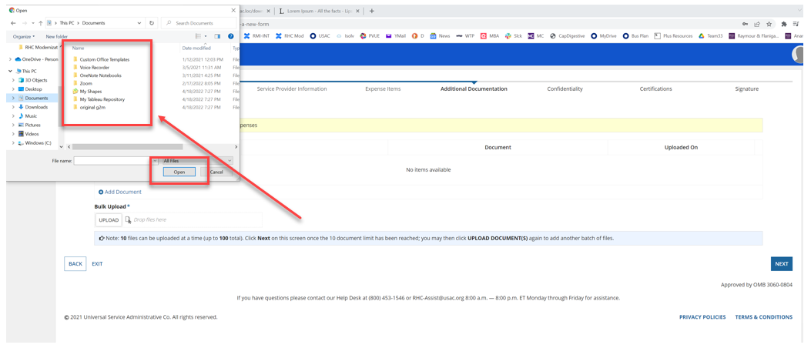

- Use the “Shift” key on your computer to select multiple files

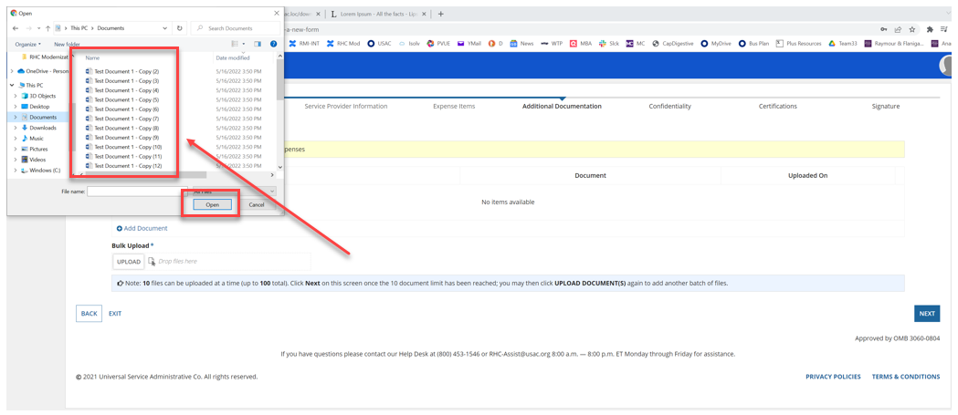

- Click “Finalize Bulk Upload”

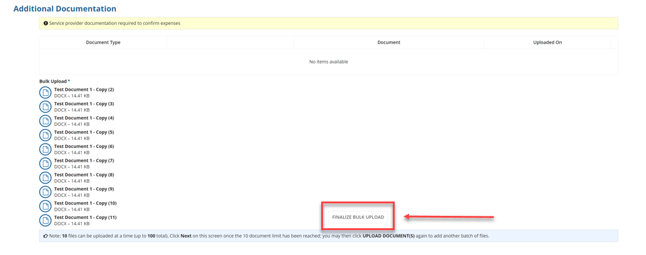

- Choose a “Document Type” from the drop-down menu
  - If you select “Other”, you are required to enter a description of the document in the free-text field

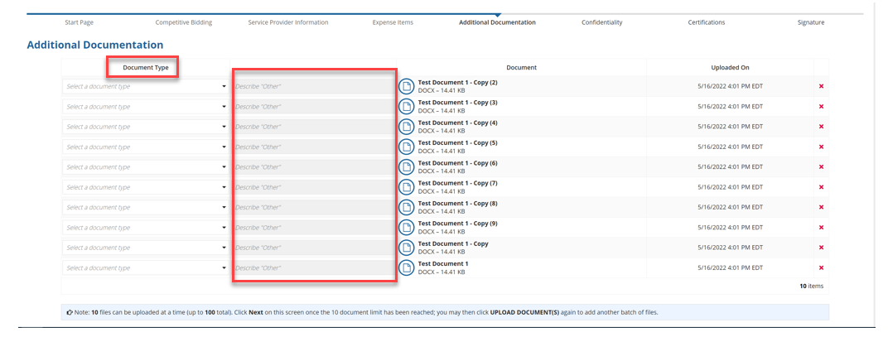

- Once you have uploaded the first 10 documents, click “Next”

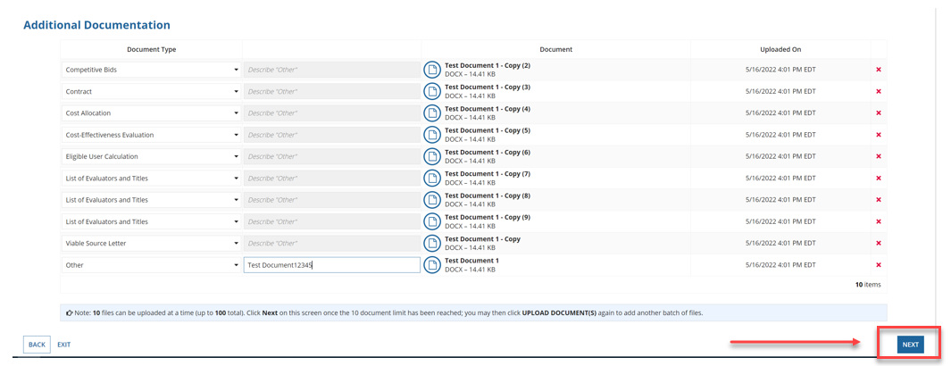

- To continue to upload documents, Click “Upload Document (s)”

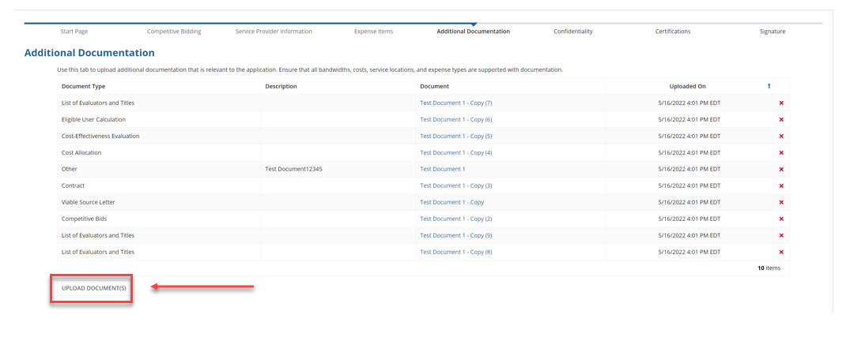

- Once all documents are uploaded, continue with next steps.

